**Software Requirement Specification (SRS)**

**for**

**ONLINE METRORAIL TICKET BOOKING SYSTEM**

1. **INTRODUCTION**Online Metro rail Ticket Booking System is a web-based system that allows users to purchase online metro-rail tickets from any location in Dhaka City. Online train is a completely new addition to our day-to-day mass transit medium. Because it is a new mass transportation system, we wanted to make it easily available to the people of our nation. Online tickets management system is a full fledge online based system.  
   Our Country is a small part of South Asian region with 165.6 million (2019) people and Dhaka is 3rd most densely populated city in the whole world. People from all over the country comes to the capital in search of livelihood, so public transport is the sole way of many people to travel from home to their workstations and people has to spend their valuable time by waiting in line to get on a bus to go to work also because of the narrow roads and rickshaws traffic jam is meant to happen which doubles the stress and kills more time. As online train is a new addition to the public transport sector people will start to rely on it on daily basis, so to remove the hassle of booking ticket from physical stations and long waiting ticket lines our project will help them on the process. People can sit on their house and book ticket to their respective destination at any given time and depart for their workstations with any hassle.
2. **SOLUTION DESCRIPTION**
   1. **System Features**

***User:***

The user can register into the system with his/her e-mail

The user can login into the system

The user can log out from the system

They use that can view his or her own profile

The user can view the location of the train

The user can purchase ticket

The user can file a complaint if there is any

The user can see the number of station nearby him/her and available trains

The user can have both language option in Bangla and English

The user can choose to pay for the purchase ticket by MFS or by MasterCard

***Admin:***

Admin can see his own profile

The admin has both login and logout function

The admin can see the total number of purchased ticket

The admin can see the available trains and the schedule of the trains

The admin can see complaints of the users

The admin can see complaints that have already been solved by that stuff

The admin can change the train time schedule

The admin can also insert or delete users

* 1. **UML Diagrams**
* **Use-Case Diagram:**

In an online train ticket booking management system, a user can choose system interface language which can be in any language a user wants (English/ Bangla). Then user gives email information to register in to the system and the system verifies the username and password and a verification email is sent to user whenever he/she registers for the first time on some software system. Then user logs in to the account with his user id and password, then the system checks if the given user id and password is valid or not. Then the user books ticket by filling information about his destination, and time. After that user applies for available ticket and the system checks if ticket on that specific time is available or not. The user can also get update of current position of the train from an Admin and the admin gives information with help of GPS tracking. After the ticket booking the user has to do payment for the ticket, He can pay by his B-kash wallet, rocket or visa/master card. The user can also register any kind of complain regarding ticket booking and late arrival of train which will be processed by the Admin.

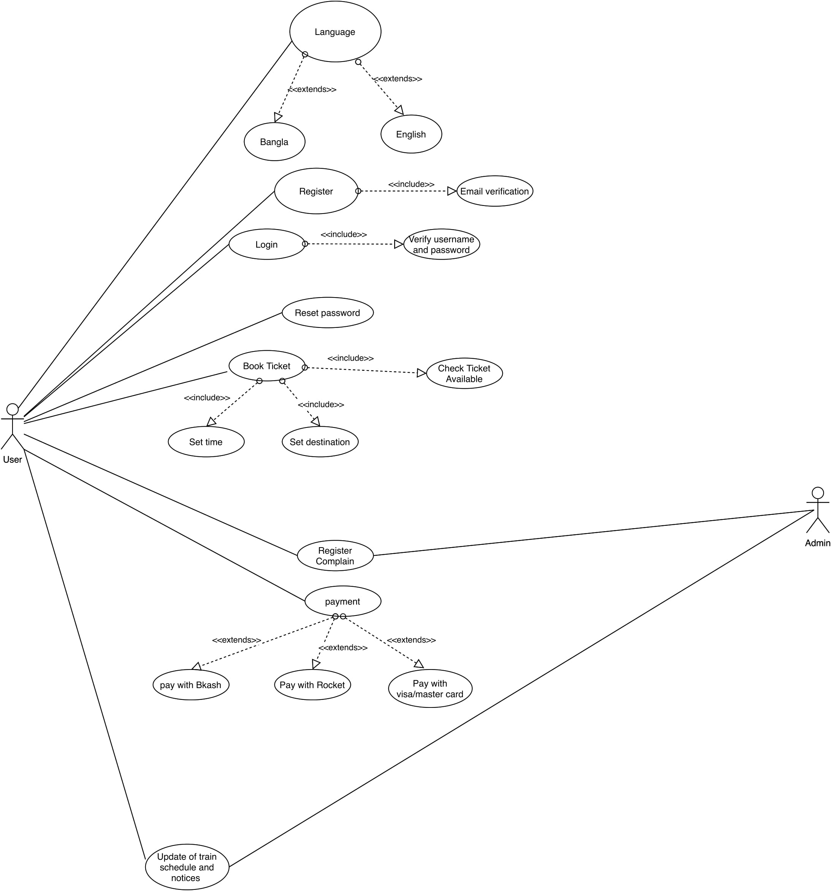

**Fig-1: Use Case Diagram for OMTBS**

* **Activity Diagram:**  
  The user registers for the first time with email information and the system checks if the information is valid or not uses then he enters login id and password to login to the system. The system checks if the login id is valid or not if the information is valid the user has logged in the system successfully. Then the user selects the destination and time to book a ticket. Then the system checks if the ticket is available for certain time. If the ticket is available, the user proceeds to make payment for the ticket otherwise the user has to request ticket for different time and date. After that the user can proceed to make payment. If the payment is successful, the system sends notification to the user with confirmation and Ticket Number. If the payment is unsuccessful the user is requested to make the payment again.  
  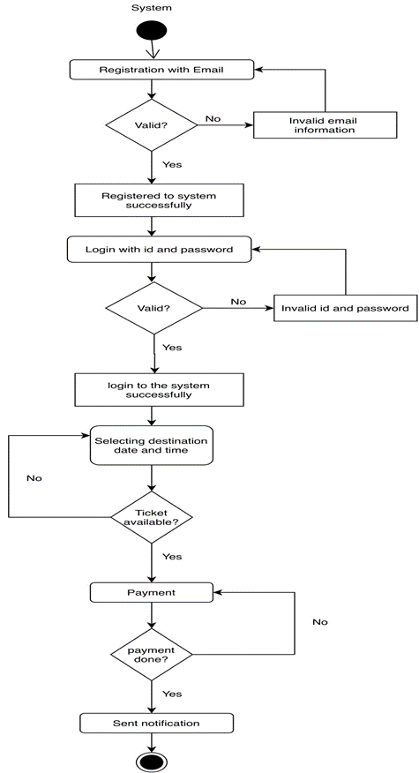  
    
   **Fig-2: Activity Diagram for OMTBS**
* **Class Diagram**In an online train ticket booking management system, a user registers for the first time with email information and the system checks if the information is valid or not then the user logs in to the account with his user id and password, then the system checks if the given user id and password is valid or not. Then the user books ticket by filling information about his destination, and time. One user can book 1 or more tickets. The user can also get update of current position of the train and the system gives information with help of GPS tracking. After the ticket booking the user has to do payment for the ticket, the user can also register any kind of complain regarding ticket booking and late arrival of train which will be inspected by the Admin. A user can register 1 or more complains.  
  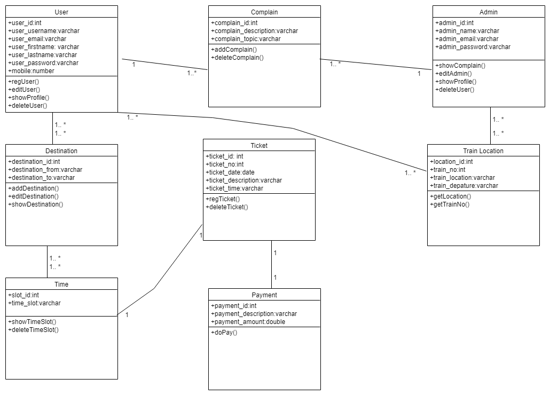  
   **Fig-3: Class Diagram for OMTBS**
* **E-R diagram:**Our System is to book tickets for online train system. Our primary goal is to make booking ticket easy for the passengers. The passenger will select a destination for booking ticket. Then he/she has to choose time to book the ticket and lastly make payment to finalize it. There will also be an admin who will oversee train schedule. The passenger can also register complain in the system which will be overseen by admin.  
  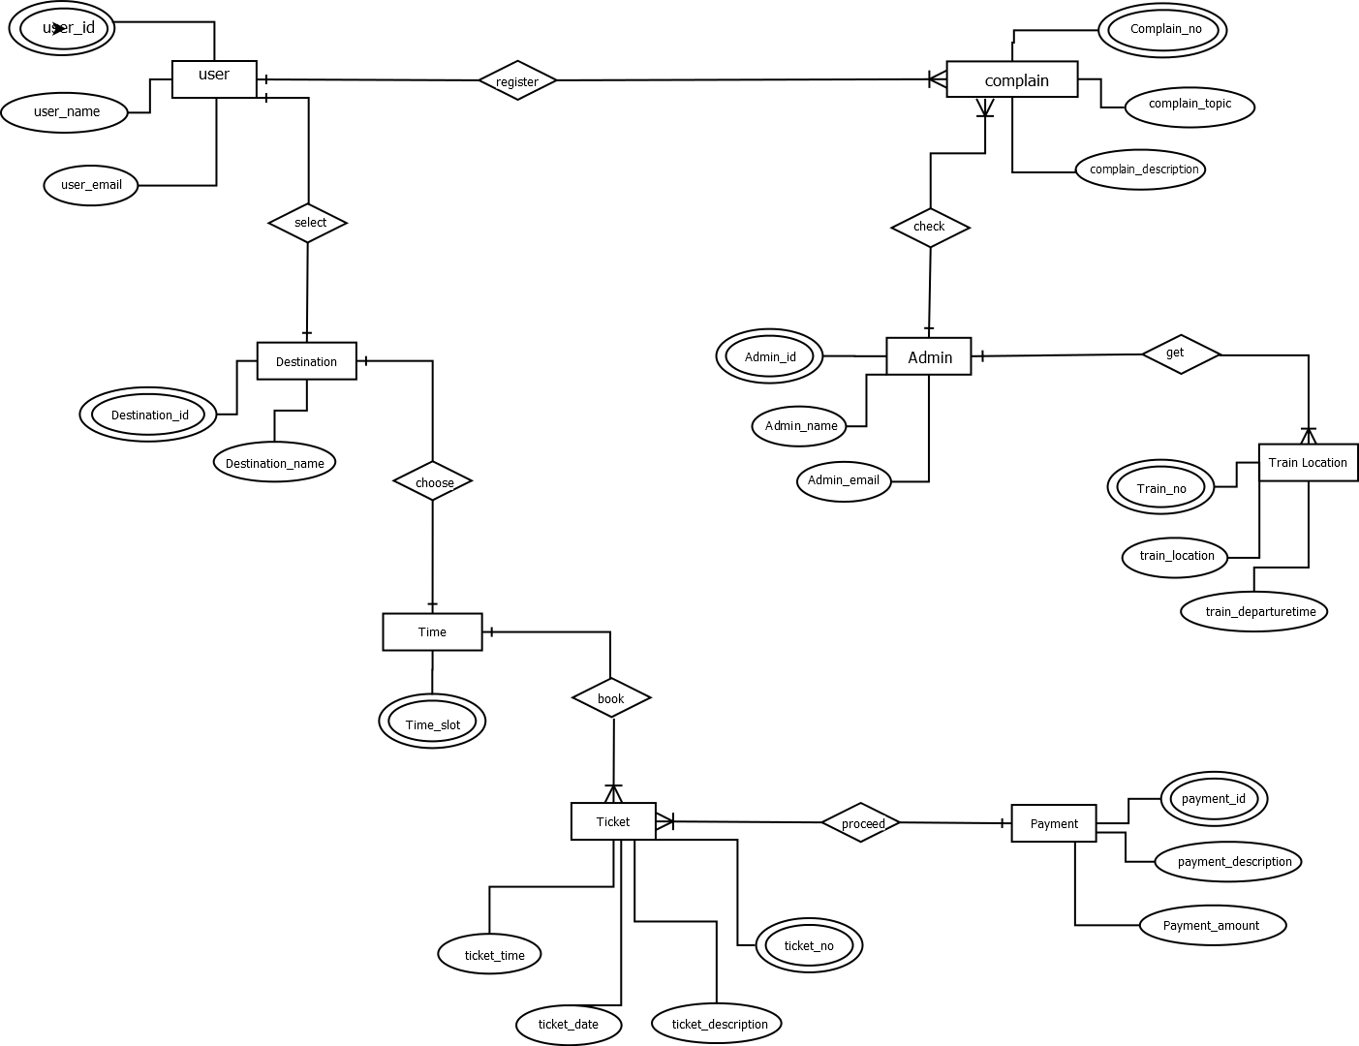

**Fig-4: E-R Diagram for OMTBS**

**3. Mockup**

***User Dash-board* :**

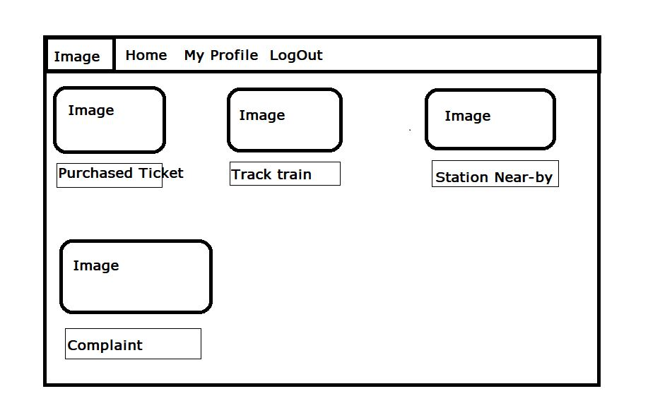

***Admin Dashboard:***

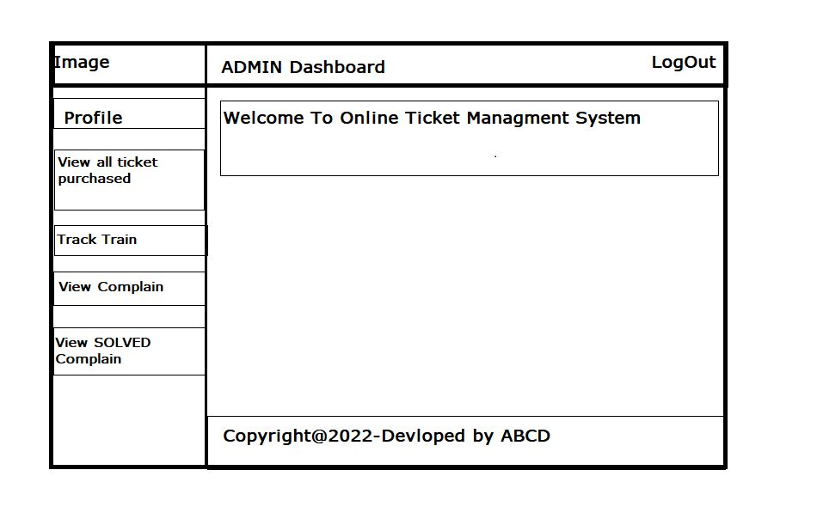

**4. Marketing Plan**

We can run different marketing plans to promote our app to the user. These plans can be short-term, long term and continuous because we need to reach out to a wide number of users so that they can get benefits from our invention. So we have planned 3 ways of the marketing plan so that we can reach out to people who will be our potential customers.

**Short term plan**

* Running Campaign
* Distributing flyers
* Advertising in printed /online news portal

**Long term plan**

* TV advertisement
* Billboard

**Continuous plan**

* Facebook Advertisement
* YouTube advertising